Serving Vegetarian Meals in School Nutrition Programs

Webinar Recipe Resources

Recipe Resources

- The Vegetarian Resource Group, quantity recipes: http://www.vrg.org

- Recipe Finder for standardized recipes, quantity recipes, and USDA recipes: http://www.whatscooking.fns.usda.gov/

- Healthy School Lunches, Resources from the Physicians Committee for Responsible Medicine:
http://www.pcrm.org/health/healthy-school-lunches/resources/school-lunch-vegetarian-recipes

- New York Coalition for Healthy School Food’s Recipes: http://www.healthyschoolfood.org/recipes.htm

- Culinary Centers, California: http://www.californiahealthykids.org/fm_recipes

The following are samples of recipes from various sources. They are not all standardized recipes, but may provide ideas for developing recipes for your program. They may be tested in these smaller amounts and then converted for your program using reference #5, the Culinary Centers, which has information on standardizing a recipe and using the standardized recipe template.

Sample Recipes

From the Physicians Committee for Responsible Medicine
Using two enchiladas per serving, this recipe serves 48 and includes ½ cup black beans, or 2 oz eq meat/meat alternate. The grains oz eq would depend on the weight of the whole grain corn tortillas. This is an example of a simple recipe with minimal ingredients.

Black Bean Enchiladas
12 medium onions, finely chopped
1½ cups water
24 cups cooked black beans (3 quarts)
12 cups medium taco sauce (¾ gallon)
96 small corn tortillas
2 bunches scallions, thinly sliced
3 cups chopped black olives
- Saute the onion in the water until tender. Place onion and black beans in a blender or food processor and puree.
- Heat the taco sauce in a frying pan. Simmer each tortilla in the sauce until just soft. Don’t overcook, as the tortillas may begin to disintegrate. Lay the tortilla flat on a cutting board or other flat surface. Place 1/4 cup of the bean mixture in the center of the tortilla and roll it up. Place it seam side down in a baking pan.
- Arrange enchiladas in a single layer in baking pans and pour any remaining taco sauce across the top. Sprinkle tops with scallions and black olives. Bake, covered, at 350° F until heated through, about 20 minutes.

From Food Network Magazine
This recipe could be easily adapted, and makes 4 patties containing 2.5 oz eq of meat/meat alternate per patty. The recipe is adapted from one by Ree Drummond. The patties do not shrink when cooked.

Black Bean Burgers
2 cups canned, seasoned black beans, drained
1 cup seasoned breadcrumbs
¼ grated onion
½ teaspoon chili powder
1 large egg
Salt and pepper

- Mash the beans until they are mushy, but still have some whole bean pieces throughout.
- Mix the other ingredients into the beans. Add a splash of water if it looks dry.
- Set aside for 5 minutes.
- Divide the mixture into 4 equal balls (measure this so if you try a larger quantity you will know what size to make the patties).
- Form into patties.
- Grill or bake.

From Rachel Ray

This recipe makes 6 patties containing 3 oz eq of meat/meat alternate.

Falafel

1 cup (12 ounces) dry chickpeas
1 teaspoon baking soda
½ cup mixed fresh herbs such as mint, parsley, cilantro, dill
¼ cup lemon juice
3–4 Tablespoons water
1 Tablespoon flour
1 large cloves of garlic
1 teaspoon coriander
1 teaspoon ground cumin
1 teaspoon sumac
½ teaspoon crushed red pepper or Aleppo pepper
¹/₈ teaspoon ground allspice
Salt and pepper

- Cover the chickpeas and baking soda with water. Let sit overnight. Or pour boiling water over and let sit 1 hour. (Or used canned)
- Drain the chickpeas.
- In a food processor, add the remaining ingredients.
- Pulse until it looks like coarse sand.
- Cover and refrigerate 1 hour.
- Make into 6 patties about 4 inches in diameter. (Measure for future reference.)
- Grill or bake
.

From 2015 Golden Carrot Awards, Presented by the Physicians Committee for Responsible Medicine

Veg-Out Chili

This recipe is from D.C. Central Kitchen and D.C. Public Schools, Grand Prize Winners for the 2015 Golden Carrot Awards, and is available at: http://www.pcrm.org/health/diets/ffl/newsletter/golden-carrot-award-winner-2015. The recipe makes 10, 6-ounce cups.

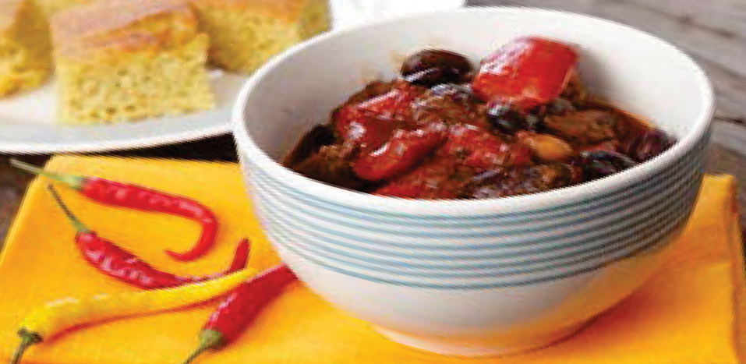
½ cup onions, chopped
½ cup green peppers, chopped
3 ½ cups kidney beans, canned, low-sodium
2 cups black beans, canned, low sodium
2 cups Great Northern beans, canned, low-sodium
2 teaspoons vegetable oil
2 Tablespoons ground chili peppers
1 teaspoon garlic powder
2½ teaspoons chili powder
1½ cups tomato puree, without salt
1 cup diced tomatoes, canned, low-sodium
¼ cup tomato paste, canned, low-sodium
1 cup water
½ cup corn kernels, frozen or cut off cob
1 teaspoon salt
¼ teaspoon ground black pepper

- Wash and chop onions and green peppers.
- Rinse and drain beans.
- In a large pot over medium high heat, add oil and sauté onions, green peppers, green chilies, garlic powder, and chili powder until vegetables are tender and aromatic.
- Add all tomato products, water, corn, salt, black pepper, and all beans and cook until flavors develop, about 35 minutes.

