Meal Claiming Presentation Script
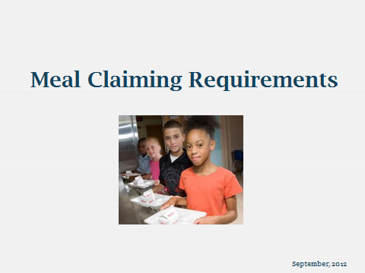

Slide 1
Good afternoon and welcome to the “Meal Claiming Requirements” presentation. Thank you for joining us.
In this presentation, we will cover the basics of Meal Claiming for the National School Lunch Program.

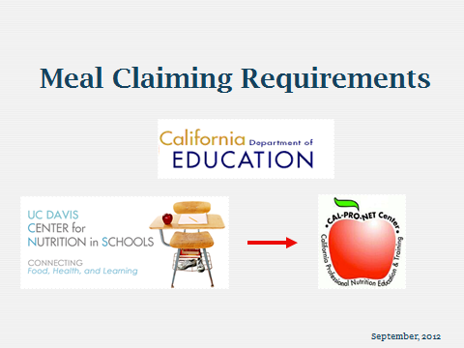

Slide 2
This webinar is brought to you by the California Department of Education, Nutrition Services Division, and the Center for Nutrition in Schools at the University of California, Davis, which is a California Professional Nutrition Education and Training, or Cal-Pro-NET center. The project manager for CDE was Louise Casias, RD, Nutrition Education Consultant with the Nutrition Services Division. The project manager for the Center for Nutrition in Schools was Dr. Marilyn Briggs, PhD, RD, Co-Director for the Center.
Louise and Marilyn are both present today and Louise will provide answers for your more technical questions.
My name is Denise Ohm. My career in school nutrition started in 1984 when I began as a substitute cook. I am currently Food Services Director at Enterprise Elementary School District. We are so excited that our program is expanding. Over the years, I have been very active in the California School Nutrition Association and even served as President in 2011-2012. I have served as a co-presenter for Cal-Pro-Net in the Financial Management classes.

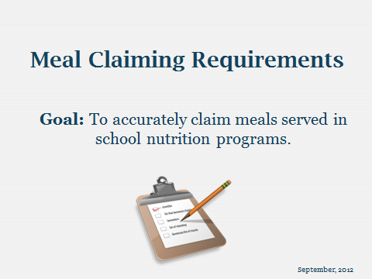

Slide 3
The goal for this webinar is to cover the basics for counting and claiming meals correctly for the school nutrition programs.
Much of this presentation is based upon the USDA Meal Counting Manual, which is included in your handouts.
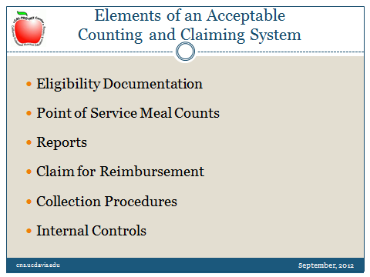

Slide 4
These are basic elements of an acceptable counting and claiming system:

- Eligibility documentation: determining the correct eligibility category for students.
- Point of Service Meal Counts: we will discuss this in more detail.
- Reports
- Claim for Reimbursement
- Collection Procedures: this includes a detailed description of the meal counting system.
- Internal Controls

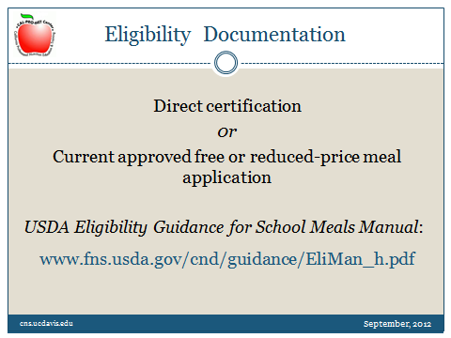

Slide 5
For meal counts to be counted in the correct eligibility category, the school must determine the eligibility of each student correctly. To ensure accuracy, all staff conducting direct certification or processing meal applications should be well trained.
There are two basic ways for students to qualify for free or reduced-price meals.
- The first is with direct certification. A list of names of students is obtained directly from the appropriate office, such as Cal WORKs or CalFresh, also known as the Supplemental Nutrition Assistance Program (SNAP) office (formerly Food Stamps), indicating that the children are members of a household receiving these benefits.
- The second is with a current approved free or reduced-price meal application. qualified by household income, using the current Income Eligibility Guideline scale.
For detailed information on eligibility and verification, refer to the USDA Eligibility Guidance for School Meals Manual (Handout #1). This manual was recently updated, in August 2012, and the changes are highlighted. The manual may also be located on the USDA web site listed here. This is the bible for eligibility and verification. All staff who deal with eligibility and verification should have their own personal copy of this manual.

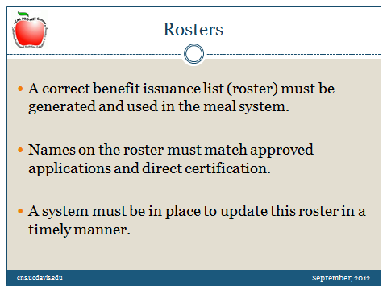

Slide 6

A correct benefit issuance list, also called a roster, must be generated and used in the meal system. Names on the roster must match approved applications and direct certification.
Also, a system must be in place to update this roster in a timely manner, as changes in students’ eligibility occur.

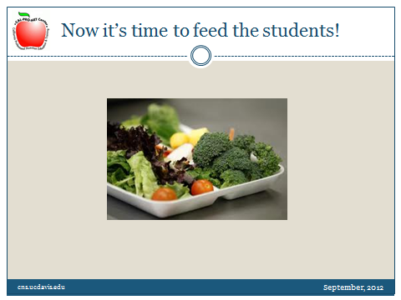

Slide 7
Now it’s time to feed the students!

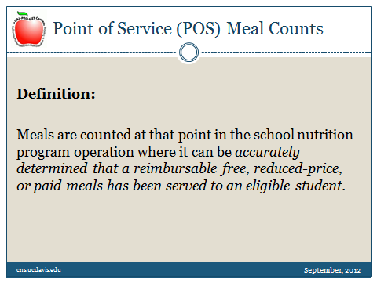

Slide 8
What does a “point of service meal counts” mean?
Meals are counted at that point in the school nutrition operation where it can be accurately determined that a reimbursable free, reduced-price, or paid meal has been served to an eligible student.
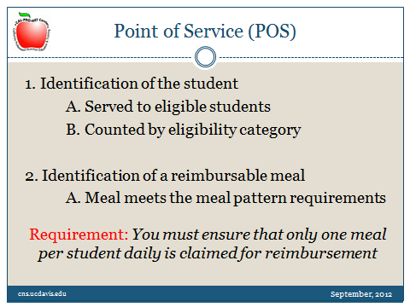

Slide 9
The essential elements of a point of service are listed here:
Meals must be served to eligible students; you cannot count adult meals.
Meals are counted in the correct eligibility category: free, reduced-price, and paid.
You must have a meal counting system, either manual or electronic, tied to the application and roster with a correct eligibility determination.
and
Count only meals that meet the meal pattern requirements for the meal served.
The meals offered must meet the meal pattern requirements. The school must offer all components in the required quantities for the grade group.
If the school is using offer versus serve, the student must take the required number of components or food items and in the correct portion size.
The meal counting system must ensure that only one meal per student per day is claimed for reimbursement. Second meals cannot be claimed in the National School Lunch or Breakfast programs.

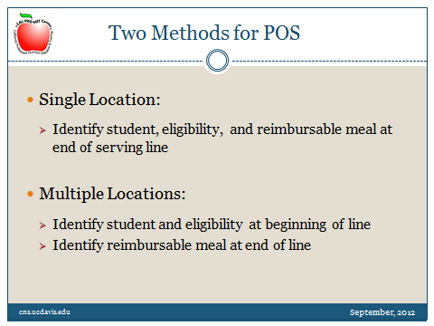

Slide 10
There are two general methods for the point of service:
- The first is where point of service verification occurs at a single location. The cashier is at the end of the serving line, the student is identified by eligibility category, the student pays for the meal if applicable, and the meal is identified as a reimbursable meal.
- The second method uses an additional point of service. The cashier is at the beginning of the line, an eligible student is identified by eligibility category, the student pays if applicable, and a second monitor is located at the end of the line to ensure that all meals are reimbursable and contain all of the required components. This seems to be the method used at most elementary schools.
Students must be counted one at a time as they go through the line. Tickets or cards may not be handed in as a group by a teacher; this is not a Point of Service meal count by student.

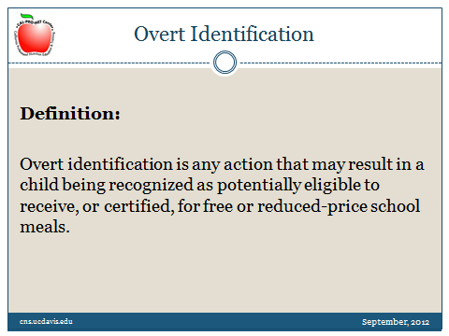

Slide 11
Schools must assure that a child’s eligibility status is not disclosed at any point in the process of providing free or reduced-price meals, including notification of the availability of free or reduced price benefits; certification and notification of eligibility; meal service in the cafeteria; or at the point of service.
Overt identification is any action that may result in a child being recognized as potentially eligible to receive or be certified for free or reduced- price school meals.

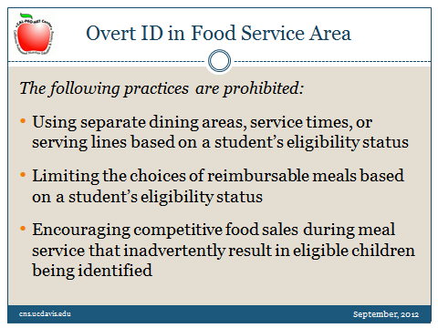

Slide 12
To prevent overt identification, the school must not treat the free and reduced-price eligible students differently than the paid students. The school must not serve meals in separate dining areas, have different serving times or serving lines, or limit the choices of reimbursable meals for the free and reduced-price students compared to the paid students.
The school must ensure that the sale of competitive foods during the meal service does not inadvertently result in free and reduced-price students being identified.
Note that a la carte sales cannot be claimed as reimbursable meals.

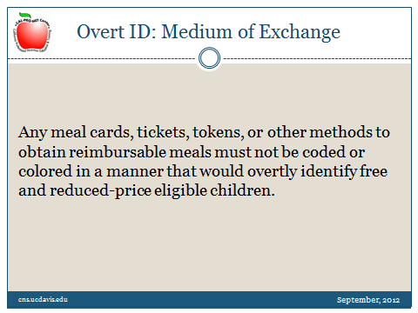

Slide 13
Of particular concern is prevention of overt identification in the food service area, especially at the point of service.
Any meal cards, tickets, tokens, or other methods to obtain reimbursable meals must not be coded or colored in a manner that would overtly identify free and reduced-price eligible children.
Schools must take steps to assure that rosters, computer-screens, or other equipment used at the point of service may not be viewed by anyone who does not need the information, especially students. The information on the rosters or screens should be masked or coded to avoid other students determining any student’s eligibility status.
Schools are encouraged to use prepayment systems as much as possible to limit the exchange of money, which may inadvertently indicate a student’s eligibility status. Schools must make reasonable efforts to publicize and encourage use of prepayment options by students and parents. Schools should also provide multiple ways to make prepayments, such as on-line, or with multiple locations within the school available when students are arriving or changing classes. Remind parents through e-mail, notices, or other means, when a student’s balance is low.
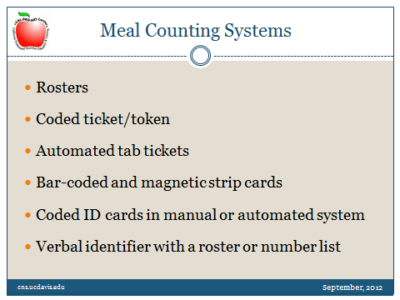

Slide 14
A variety of meal counting systems are available.
The USDA meal counting manual (Handout #2) reviews each meal counting system listed here. The manual goes into detail with the advantages and disadvantages of each system. Many of the larger school districts have a computerized meal counting system.
The meal counting system used by the school may depend upon cost, size, characteristics of the school, local preferences, the number of personnel needed to operate the system, the amount of time needed to operate the system during the meal service, as well as total the meal counts and methods for creating meal count reports.
A computerized system may save time and increase accuracy of meal counting and claiming, but also may be expensive. The school must have a back-up system to a computerized system in case of computer system failure.
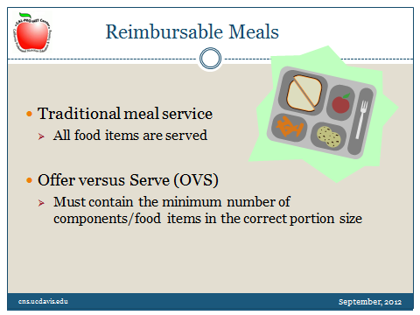

Slide 15
Only reimbursable meals may be claimed for reimbursement.
- With traditional meal service, the students must receive all of the food items. This includes the entrees, side dishes, and milk. You may see this type of meal service for field trip lunches, breakfast in the classroom, and grab and go meals.

- Many schools use offer versus serve to allow the students to decline a certain number of food components or food items, depending upon whether it is breakfast or lunch. The monitor at the end of the line must be well trained to identify if the meal contains all of the required components or food items in the correct portion sizes. If not, the meal cannot be counted and claimed for reimbursement.

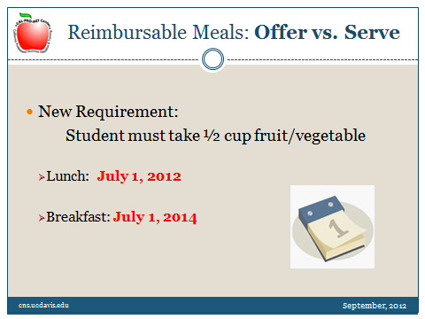

Slide 16
With the new meal pattern regulations, the student must take ½ cup fruit or vegetable, or combination of fruits and vegetables, to claim the meal for reimbursement. The timeline for this new requirement is different for lunch and breakfast. This new requirement was effective July 1, 2012, for lunch, and will be effective July 1, 2014, for breakfast. This new requirement to take ½ cup fruit at breakfast takes effect when the requirement for fruit increases from offering ½ cup to 1 cup in 2014.
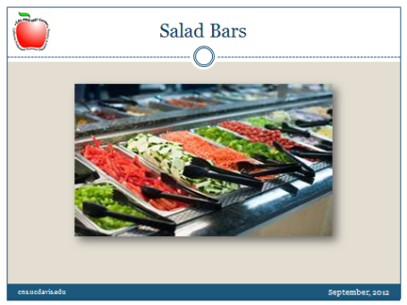

Slide 17
Salad bars have become very popular as a way to entice students to eat more fruits and vegetables, and as a way to incorporate local produce. If the fruits and vegetables are served in bulk on the salad bar, the students may be more likely to serve themselves more fruits and vegetables. The students must take at least ½ cup fruit or vegetable, or combination fruits and vegetables, to claim the meal for reimbursement. The students, cashiers, and monitors at the end of the line must be able to recognize the ½ cup serving of fruits and/or vegetables on the plate.
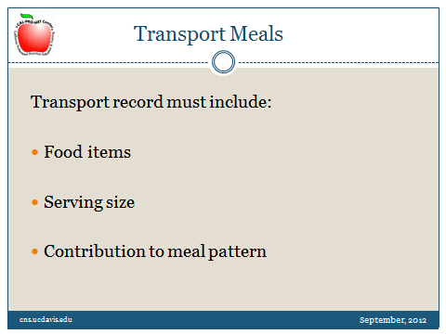

Slide 18
Because many new schools have not been built with full kitchens and because sometimes it is more economical, many districts prepare food in one location, and then transport it hot or cold to another location to be served.
In these types of circumstances, communication to the serving site is critical.
The preparation site may have planned and prepared a certain serving size or cut for a pan. If the information is not communicated and followed, the student may get something different.
The staff at the transport site must be well trained to serve the food items in the correct serving sizes. The staff must know the combinations of food items to count for a reimbursable meal under offer versus serve, and be able to recognize a reimbursable meal as taken by the student.

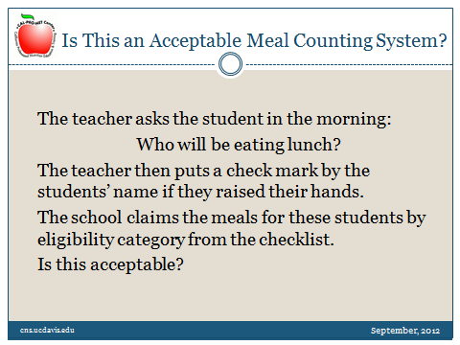

Slide 19
Now, let’s review some scenarios. This series is called “Is this an acceptable meal counting system.” [Then read slides; pause after first slide, and then go to next slide for answer.]

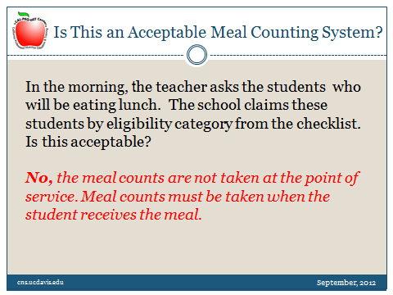

Slide 20

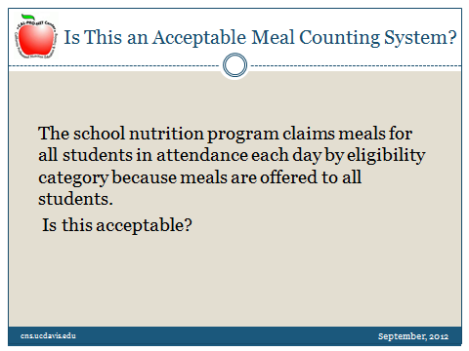

Slide 21
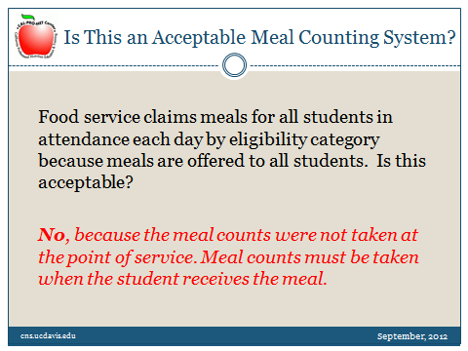

Slide 22

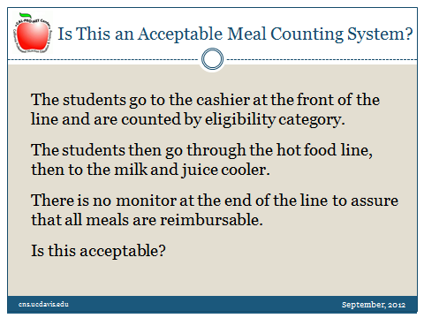

Slide 23

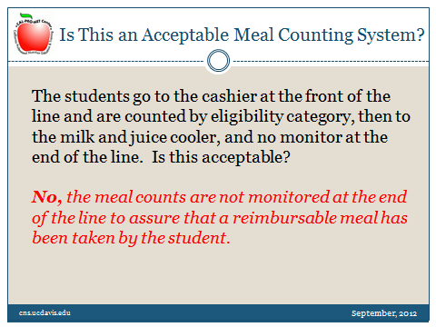

Slide 24

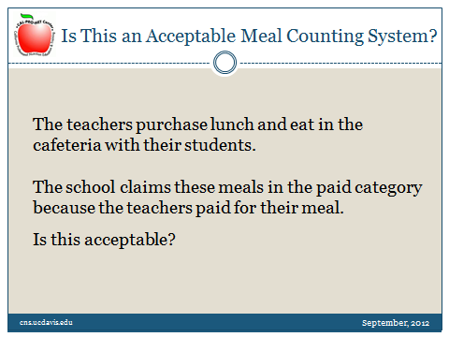

Slide 25

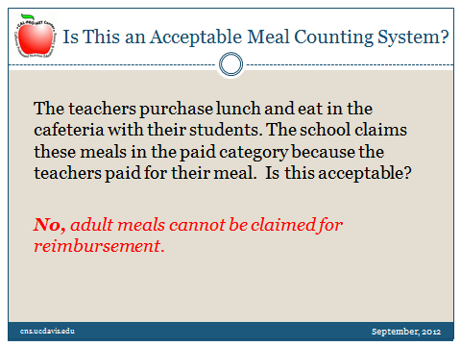

Slide 26

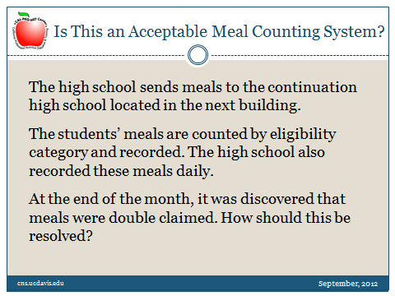

Slide 27

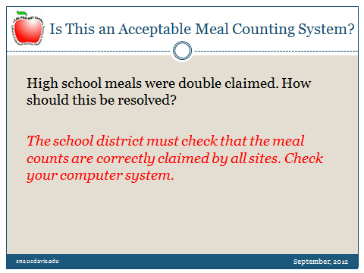

Slide 28
Read the slide
[Add as follow-up to “check your computer system:”] It was observed at one site that the computer system left off all meal counts for the 31st of each month for those months that had 31 days. The computer systems are generally very accurate, but there may be system problems. Remember to look closely and check your computer system’s accuracy.

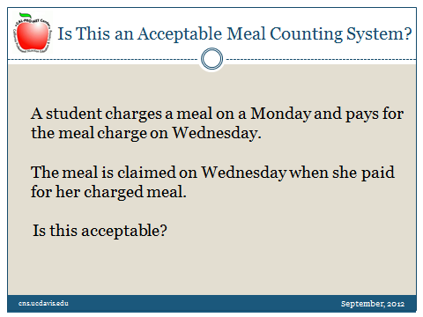

Slide 29

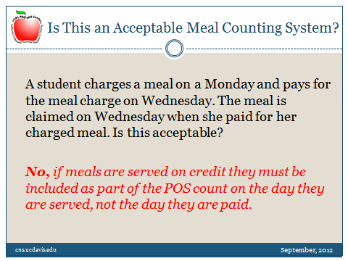

Slide 30

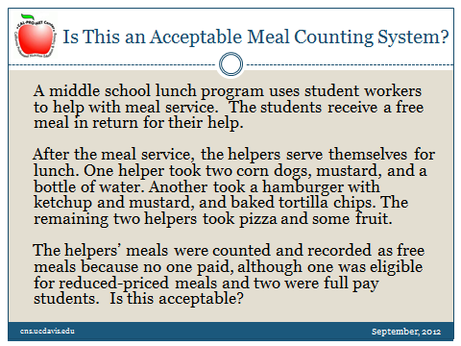

Slide 31
Read the slide

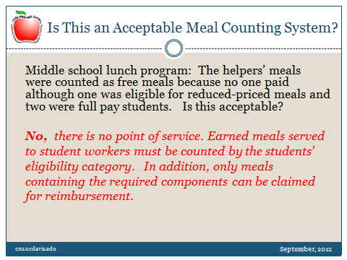

Slide 32
Read the slide
The school could have a sign-in sheet for the student workers. Make sure the meals are monitored to ensure that a reimbursable meal has been taken.
Earned student meals are claimed by category and include a point of service.
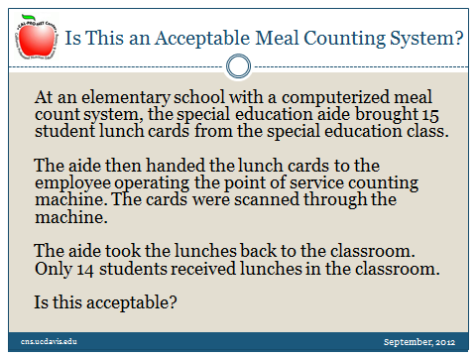

Slide 33

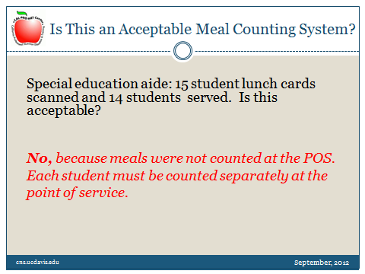

Slide 34

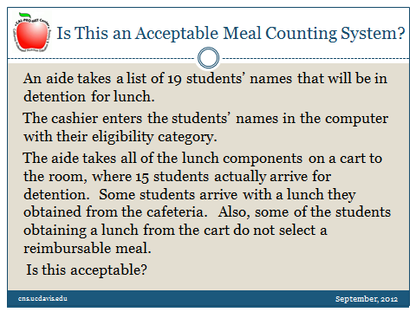

Slide 35

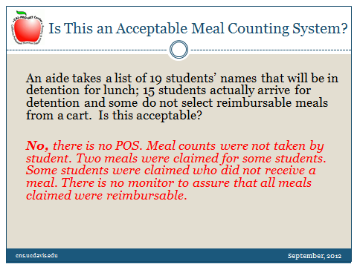

Slide 36
Read the slide.
A reviewer actually observed this situation on a site visit during a review. This scenario is an example of multiple problems. If someone with knowledge of the meal program had visited this site, he or she could have fixed the problems.

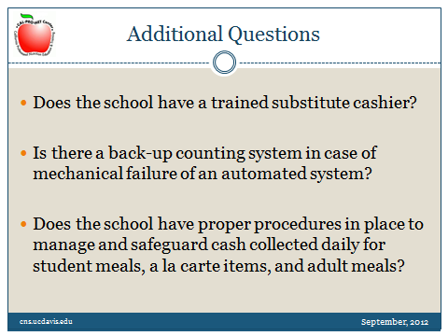

Slide 37
Here are some additional questions to ask yourself.
Read the slide

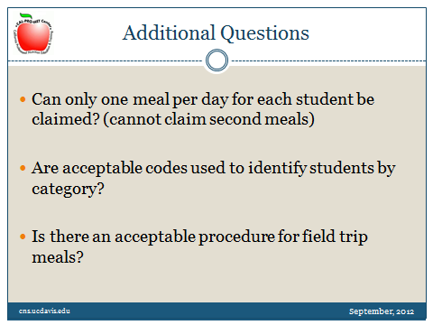

Slide 38
Read the slide

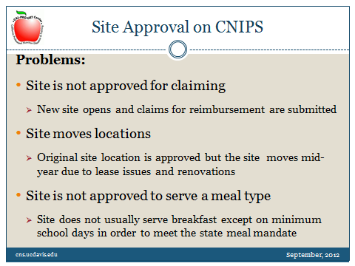

Slide 39
All sites must be approved in the CDE Child Nutrition and Information Payment System, also known as CNIPS. If a new site opens, submit a new site application in CNIPS and obtain approval. You cannot claim reimbursement for non-approved sites.
Each site is approved with the physical address, so changes in address must be approved. If the site moves location (for example, if the lease has expired or there are renovations and the site has to relocate) submit the address change in CNIPS and obtain approval.
The meal program types must be approved. These include breakfast, lunch, and afterschool snacks. If a site does not normally serve breakfast, but serves breakfast on a minimum school day in order to meet the state meal mandate, the site must be approved for breakfast. Meal claims should not be filed for breakfast if the breakfast program is not approved for that site.
If any of these problems occur, the meals will not be claimed until the sites are approved correctly.

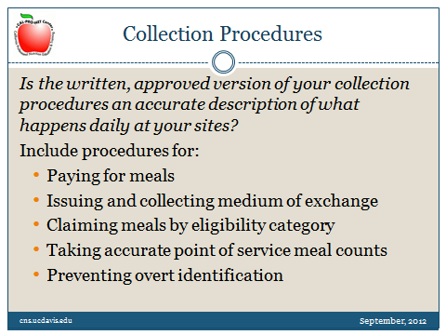

Slide 40
You must have detailed written collection procedures.
Is the written, approved version of your collection procedures an accurate description of what happens daily at your sites?
The written collection procedures must include procedures for students to pay for meals. Students must be able to pay for meals on a daily basis, including the ability for the reduced-price students to pay $0.40 each day for lunch. The procedures must also include the type of medium of exchange, how the meals are claimed by eligibility category at the point of service, and how overt identification is prevented.
Do not forget to include field trip procedures, or any other “out of the ordinary” meal circumstance, such as meals delivered to the classroom for special education or preschool students.
If meal count procedures are different at different sites, multiple meal counting procedures must be developed.
These procedures should be very specific, so that new staff may read the site meal collection procedures and know exactly what to do to obtain accurate meal counts.

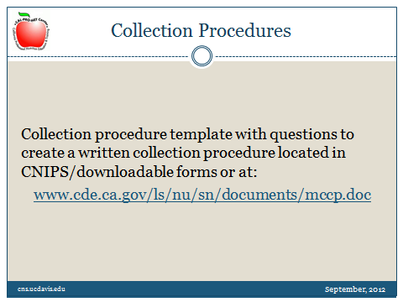

Slide 41
You can use a collection procedure template with questions to create a written collection procedure. This is located at CNIPS under downloadable forms, and is available as webinar Handout #3 or at the website listed on the slide.

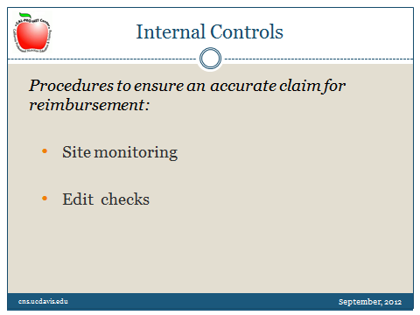

Slide 42
Internal controls are required to ensure accurate daily meal counts, which lead to an accurate claim for reimbursement.
The district is required to conduct site monitoring and edit checks.
Webinar handouts 4 through 10 provide sample forms for site monitoring and edit checks.

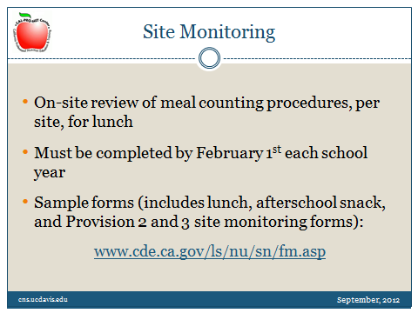

Slide 43
The district must perform monitoring visits at each site for lunch prior to February 1st of each school year. The person conducting the site-monitoring visit must observe the lunch meal from the beginning of meal service to the end, including the cash deposits and daily reports. Site monitoring is optional, but recommended, for breakfast because the meal counting procedures may be different for breakfast and lunch. If there are problems during the monitoring visit, conduct training and follow-up if necessary.
Many districts conduct site monitoring more frequently than once per year. This process is very important, especially when the site has new staff. Also, as we saw in our scenarios, early detection can be very important.
Forms are available at the web site listed on the slide and are also available as webinar handouts # 4 through 6.

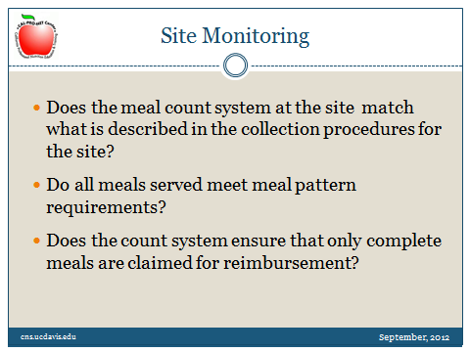

Slide 44
Here are some questions from the site monitoring forms.
- Does the meal count system at the site match what is described in the collection procedures for the site?
- Do all meals served meet the meal pattern requirements with the appropriate serving sizes?
- Does the count system ensure that only complete meals are claimed for reimbursement?
- If the site uses offer versus serve, do all meals taken by the students contain the minimum required components and serving sizes?

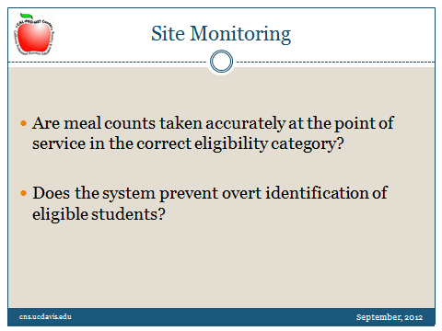

Slide 45
Are meal counts taken accurately at the point of service in the correct eligibility category? This is one of the keys to counting meals correctly.
  - The person conducting the site-monitoring visit must check all points of service. The general rule is to follow the food. If the food leaves the cafeteria, follow it to the point of service location. This may be to a special education classroom, a detention classroom, or a preschool classroom.
Does the system prevent overt identification of eligible students?
The person conducting the site monitoring visits must be familiar with the meal program requirements.

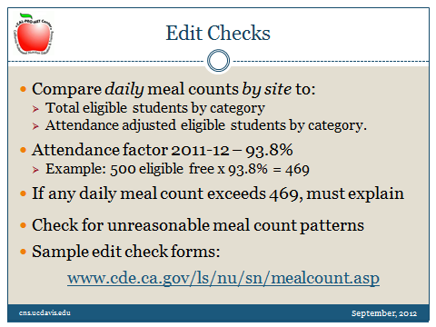

Slide 46
An edit check is required to check for high meal counts.
The edit check compares the daily meal counts by site to the total eligible students by category, and compares the attendance of eligible students by eligibility category. The attendance factor for 2011 – 12 is 93.8%. The attendance factor for 2012-13 will be released shortly. Always use the most current attendance factor to conduct your meal count edit checks.
Here is an example: if the school has 500 eligible free students, multiply 500 times the attendance factor of 93.8%. This equals 469. The school must explain any daily meal counts that exceed 469. For example, a special BBQ, or another special promotion may explain an unusual meal count.
The daily meal count may never exceed the total eligible students by category. You may use any edit check form that you like. Sample edit check forms available at the web site listed on this slide.
The computer system may be able to calculate the edit check, but just make sure that someone is actually looking at the edit check spreadsheet to determine high counts that must be explained.
The school will also want to look at unreasonable patterns in the daily meal counts. These may include:
  - Reporting the same number of lunches in one or more categories every day, or the same meal count on alternating days;
  - Reporting the number of lunches delivered to a satellite site as the number of lunches claimed each day rather than counting the meals at the point of service, and
  - The daily meal counts seem to show high percentages of free and reduced-price meal counts every day.
Patterns like these require further investigation!
Refer to webinar handouts 7 through 10 for sample edit check worksheets.

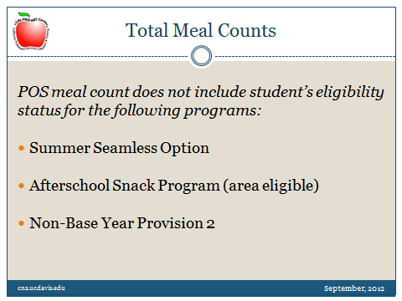

Slide 47
There are special situations when the school counts the total meals served, and does not determine meal counts by the student’s eligibility.
This occurs for meals served in the summer seamless option sites, in area-eligible afterschool snack programs, and for meals served in non-base Provision 2 sites.

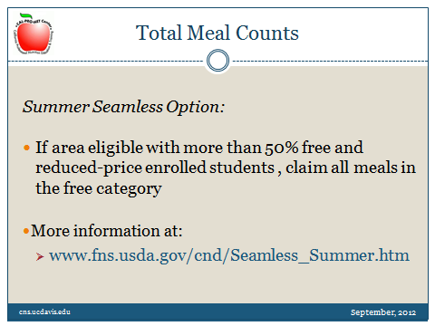

Slide 48
If the school is area eligible with more than 50% free and reduced-price enrolled students, the school may serve meals to the community and include summer school students. All of the meals are claimed in the free category for the Summer Seamless Option. If the school is not area eligible, the school cannot participate in the summer seamless option. Refer to this web site for more information on the summer seamless option.

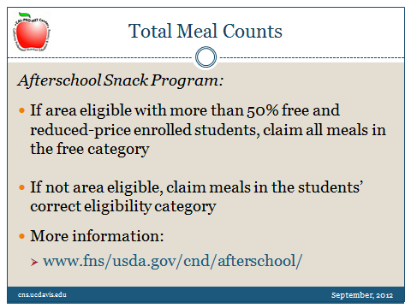

Slide 49
For the afterschool snack program, if the school is area eligible with more than 50% free and reduced-price enrolled students, all of the meals are claimed in the free category. If the school is not area eligible, the school can participate in the afterschool snack program, but must claim the snacks in the student’s eligibility category.
Refer to this website for more information on the afterschool snack program.

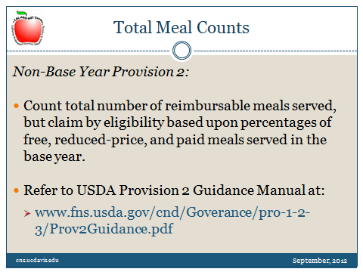

Slide 50
If a school is in a non-base year for Provision 2 alternative claiming, they can count the total number of reimbursable meals served. The meal counts by eligibility are determined based upon the percentages of free, reduced-price, and paid meals served in the base year.
Refer to the USDA Provision Guidance Manual at the USDA website listed on the slide for detailed information.

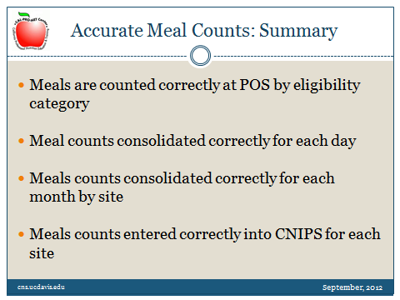

Slide 51
Just to summarize:
The goal is to accurately claim meals served to students in the child nutrition programs.
- To do this, meals must be counted correctly at the point of service by the correct eligibility category
- Meal counts must be consolidated correctly for each day
- Meal counts must be consolidated correctly for each month by site
- And meals counted must be entered correctly into CNIPS for each site.
Then, the school district will receive the correct reimbursement for meals served.

Slide 52
[Resource slides, below, added to address participant questions, providing additional information:]

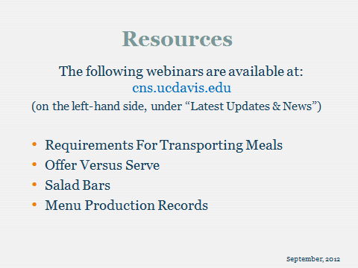

Slide 53

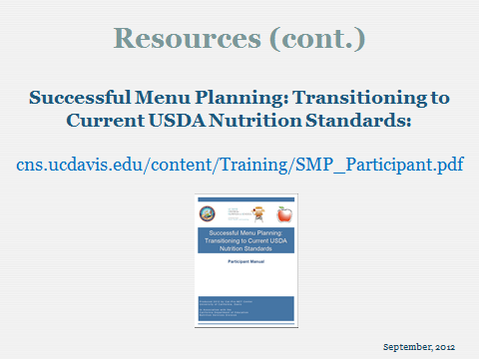

Slide 54

